CSCI 2170: Lab 1

Web Development and Browser Testing

Submission Date: [9/13/2024]

**Table of Contents**

Student Information

Web Browsers Used

Task 1: Website Analysis

Observations:

Task 3: Browser Testing

Observations:

Final Observations

Observations:

## 

## 

## 

## 

## 

## 

## 

## 

## 

## 

## 

## **Student Information**

- Name: [Javier Wahn]

- Student ID: [B00935618]

- Email: [jv513910@dal.ca]

## **Web Browsers Used**

- [Mozilla Firefox]

- [Microsoft Edge]

## **Task 1: Website Analysis**

Observe the activities in the Network tab. Pay close attention to changes in the "Name" column.

* + Click on the first item under the "Name" column in the Network tab.
  + Observe the **headers** and **responses** displayed in the developer tools for this first item, pay extra attention to cookie and other information that is sent as part of the request and responses.
  + Take screenshots of your observations and include them in your report.

1. Perform the above activity with both the browsers that you choose.
   * Compare the headers and responses of this first item with those of subsequent items in the Network tab.
   * Note down **at least 2 differences** that you observe between the two browsers.

### **Observations:**

Microsoft Edge

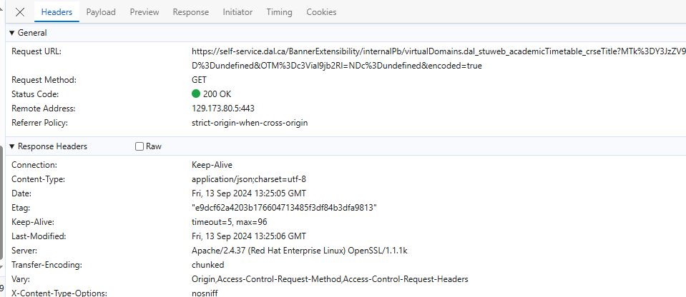

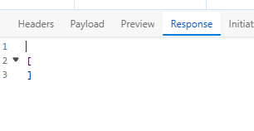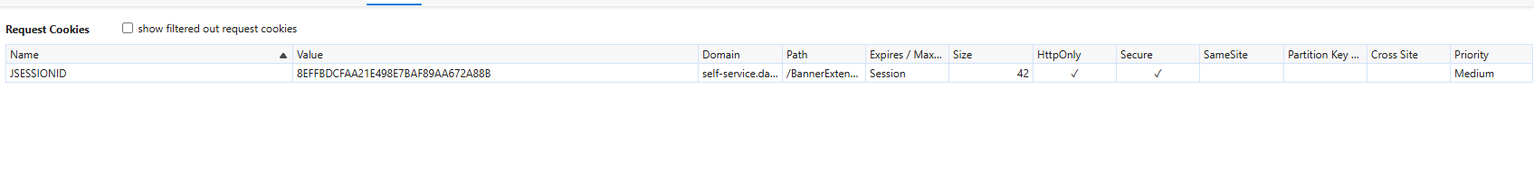

Firefox

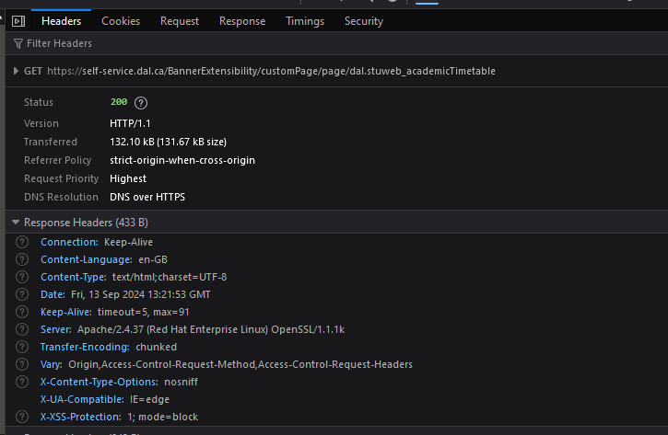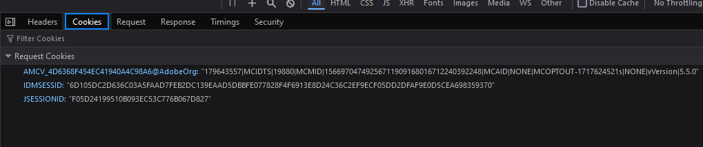

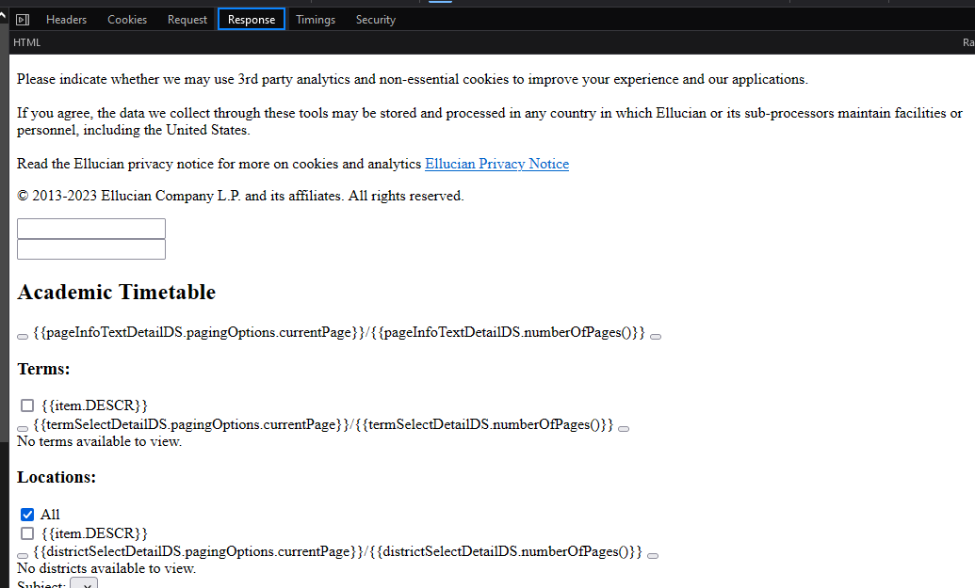

- [Type your observations for Task 1 here]

When Looking through the other items in the network list we can see that some come with different status codes in the header section (such as 304, 200) or that some files are reloaded from the disk cache rather than being re-requested to the server. We can also notice that some other items don't have a cookies tab (i.e in the media files like gifs or jpg files)

Differences between browsers:

-the firefox browser display file names in the “file” column rather than the “name” column that microsoft edge uses.

-In the header section firefox display the version of HTTP used to make the request while edge Lacks that

-Edge display the IP address from where the file was received while firefox lacks this

## **Task 3: Browser Testing**

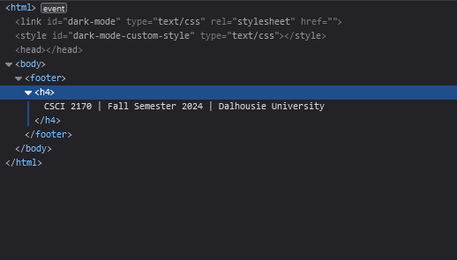

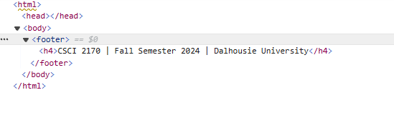

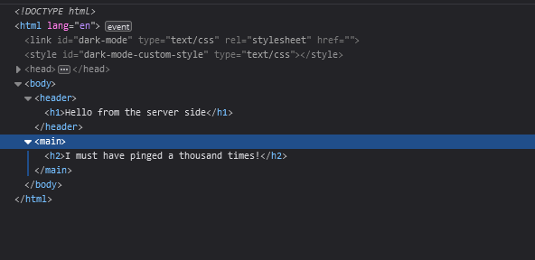

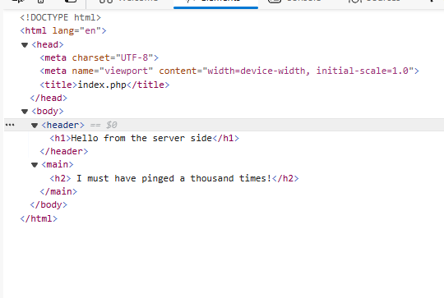

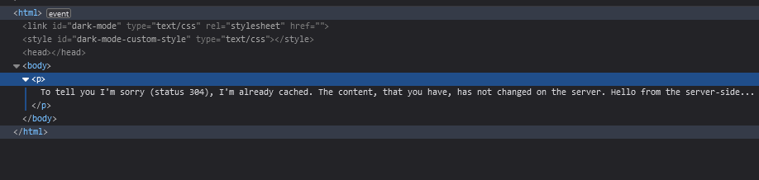

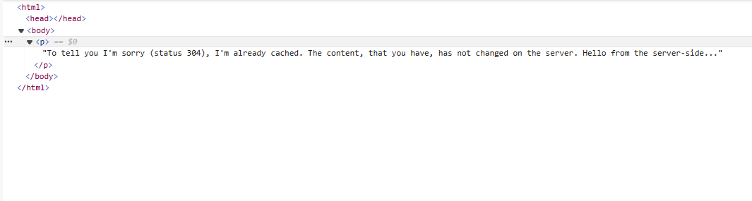

### **Observations:**

- [Type your observations for Task 3 here]

I've reloaded the page multiple times and both browsers seem to receive information for all three pages in the same manner for the inspect tab.

On the other hand in the network section I was able to notice that each browser requests headers that it's requesting the server the php files specifically for “chromium” and “mozilla firefox”, meaning that some modifications are needed on the php file to be received on each browser.

On microsoft edge I was also able to notice that the remote address given wasn't an IP like for the dal timetable items, rather it was a special code for localhost : [::1]:80.

## **Final Observations**

The final task involves compiling your observations from Tasks 1 and 3 into this section. After that rename the file with you B00# and convert it into a pdf for submission.

### **Observations:**

- [Type your combined observations for Task 1 and Task 3]

After observing the browser behaviour of microsoft edge and firefox we were able to see that both have different protocols for requests, headers and different ways of displaying this information (or lacking in display such information), we also observed how both browsers interacted with the php files we made and how the server accommodates for different browsers when responding to requests.